**Lab 1 Deliverables**

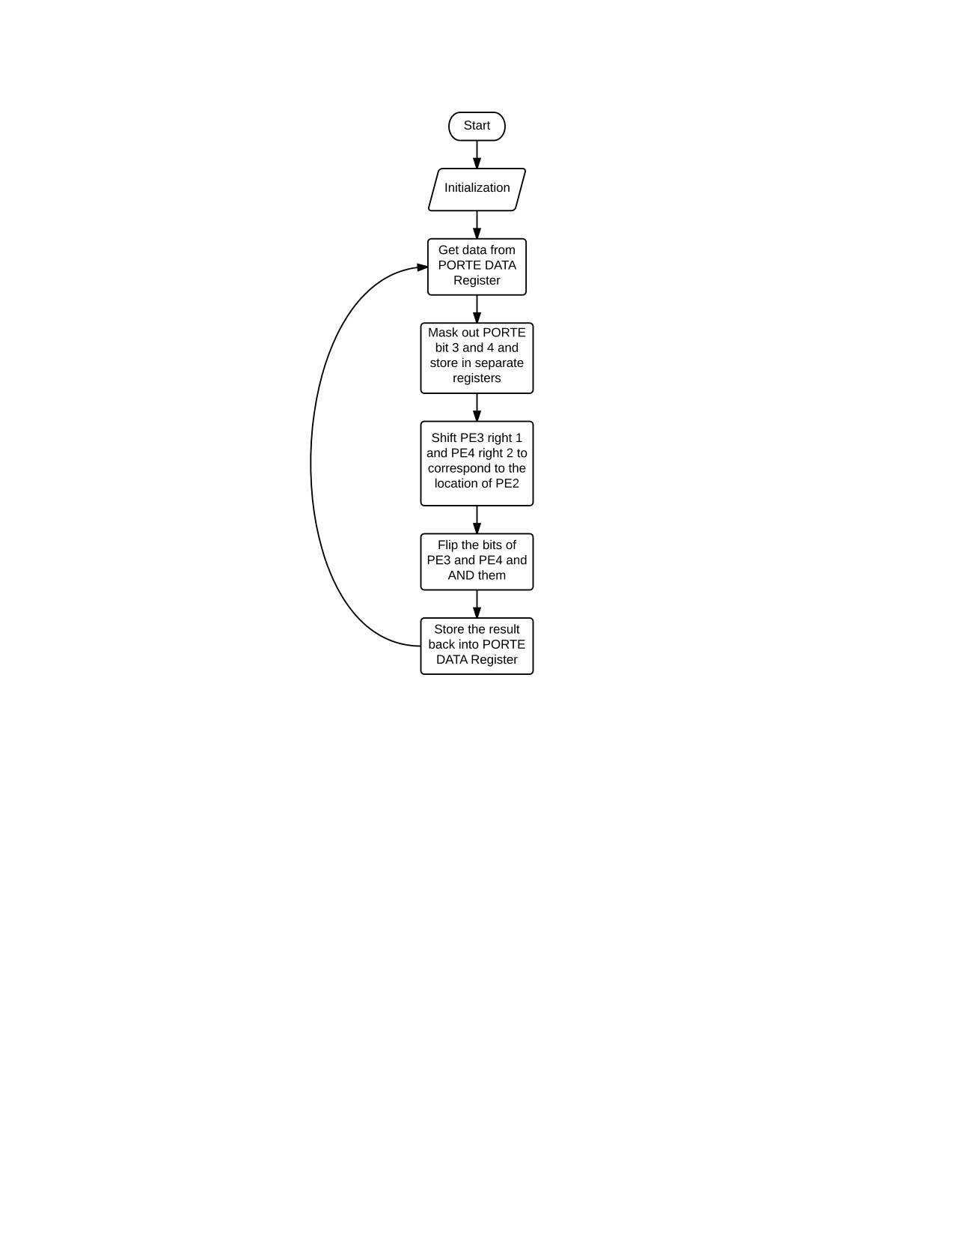

main Turn on clock for Port E

Set the Port E direction register so

PE4 and PE3 are inputs

PE2 is output

Disable Port E alternate function

Enable PE4 and PE3 in Port E DEN register

loop Read the Port E data register

Mask out value of PE4

Mask out value of PE3

Not the value of PE4 and PE3 and AND them

Store result in PE2 in the Port E data register

Go to loop

;****************** main.s ***************

; Program written by: Ali Ziyaan Momin, Zain Modi

; Date Created: 9/8/2015

; Last Modified: 9/8/2015

; Section 4-5pm WED TA: Jenny Chen

; Lab number: 1

; Brief description of the program

; The overall objective of this system is a digital lock

; Hardware connections

; PE3 is switch input (1 means switch is not pressed, 0 means switch is pressed)

; PE4 is switch input (1 means switch is not pressed, 0 means switch is pressed)

; PE2 is LED output (0 means door is locked, 1 means door is unlocked)

; The specific operation of this system is to

; unlock if both switches are pressed

GPIO_PORTE_DATA_R EQU 0x400243FC

GPIO_PORTE_DIR_R EQU 0x40024400

GPIO_PORTE_AFSEL_R EQU 0x40024420

GPIO_PORTE_DEN_R EQU 0x4002451C

GPIO_PORTE_AMSEL_R EQU 0x40024528

GPIO_PORTE_PCTL_R EQU 0x4002452C

SYSCTL_RCGCGPIO_R EQU 0x400FE608

AREA |.text|, CODE, READONLY, ALIGN=2

THUMB

EXPORT Start

Start

BL PortE_Init ;initialize port E input outputs

loop

LDR R1, =GPIO_PORTE_DATA_R ; Load address for Port E data register

LDR R0, [R1] ; Load contents of Port E data register

AND R2, R0, #0x10 ; Mask PE4 and put in R2

AND R3, R0, #0x08 ; Mask PE3 and put in R3

ASR R2, #2 ; Shift right PE4 2 places

ASR R3, #1 ; Shift right PE3 1 place

EOR R2, R2, #0xFF ; NOT PE4

EOR R3, R3, #0xFF ; NOT PE3

AND R2, R2, R3 ; AND values of PE4 and PE3

STR R2, [R1] ; Put the result back into the Port E data register

B loop

PortE_Init

LDR R1, =SYSCTL_RCGCGPIO_R ; 1) Activate clock for Port E

LDR R0, [R1]

ORR R0, R0, #0x0010 ; Set bit 4 to turn on the clock

STR R0, [R1]

NOP

NOP ;allow time for clock to finish

LDR R1, =GPIO_PORTE_DIR_R ; 2) Set direction register

LDR R0, [R1]

ORR R0, R0, #0x04

AND R0, R0, #0xE7 ; PE4 and PE3 are inputs(0) and PE2 is output(1)

STR R0, [R1]

LDR R1, =GPIO_PORTE_AFSEL_R ; 3) Regular port function

MOV R0, #0x00 ; 0 means alternate function disabled

STR R0, [R1]

LDR R1, =GPIO_PORTE_DEN_R ; 4) Enable Port E digital port

MOV R0, #0xFF ; 1 means enable digital I/O

STR R0, [R1]

BX LR

ALIGN ; make sure the end of this section is aligned

END ; end of file

